**CHAPTER 1**

**INTRODUCTION**

As the name suggests, the I-D card generator system will help in generating ID cards to the employees of the enterprises or the students of the institutions with great ease. This application will help in having only one ID card for a person. This will also ensure that there is no forgery in the generation of the ID card. It will help in generating a huge bulk of ID cards without any confusion. It will help in detecting any forgery that is done in the ID – card generation. This will be one of the unique and interesting projects that one can work on and get good marks in the examination. The features that can be included in the I-D card generation system are as follows:

* DATABASE MANAGEMENT OF THE EMPLOYEES OR STUDENTS: The ID cards can be generated in bulk for the employees or the students who are need of it. This is possible by feeding data from database to the program by altering the code that is used for the project.
* UNIQUE IDENTITY: I-D cards will give unique identity to each and every person in the organization or the institution.
* NO FORGERY: There will be no forgery in the ID card generation for the students or the employees. This will be unique for each and every person.
* FEATURES: This application will help in providing various features like generation of unique qrcode for each employee.

In the enterprises there will be something called as visitors id. Even this visitors ID can be created then and there in the name of the particular visitor itself. This system will help enterprises issue ID cards with ease. One such project will see that no one gets more than one ID card. The user interface must be simple and easy to understand. This will be a useful project for the enterprises and the institutions which will reduce their work.

**CHAPTER-2**

**DESIGN AND ARCHITECTURE**

Start

pip install qrcode

import os,datetime,qrcode,random

createID(position.font,message)

#create an image

image = Image.new('RGB', (1000,900), (255, 255, 255))

draw = ImageDraw.Draw(image)

font = ImageFont.truetype('arial.ttf', size=45)

color=black txt=message.upper()

#paste the txt in image draw.txt(position,txt,color,fon

Output:

+++++++++++++++++++++++++++++++++++

date ID CARD GENERATOR time

+++++++++++++++++++++++++++++++++++

Return

Output:

All Fields are Mandatory

Avoid any kind of Spelling Mistakes

Write everything in uppercase letters

Input:

message=Enter Company name:

Set: position, font(size=80), name=message

createID (position.font,message)

1

1

#random id is generated between 10000000-90000000

Set: idno=random_integer message='ID'+idno position,font(size=45)

createID(position.font,message)

message=Enter name:

Set: position,font(size=45) name=message

createID(position.font,message)

message=Enter gender:

Set:

position

2

2

createID(position.font,message)

message=Enter age:

Set:

position

createID(position.font,message)

message=Enter DOB:

Set:

position

createID(position.font,message)

3

3

message=Enter Blood group:

Set:

position

createID(position.font,message)

message=Enter mobile number:

Set:

position

createID(position.font,message)

4

4

message=Enter address:

Set:

position

createID(position.font,message)

Save image as name.png

create qrcode.make(str(company)+str(idno))

insert qrcode in image save image

ID card successfully generated

Display ID Card image.show()

Stop

**CHAPTER-3**

**IMPLEMENTATION**

**MODULE AND PACKAGE EXPLANATION:**

* PIL: pil is the Python Imaging Library. The Python Imaging Library (PIL) adds image processing capabilities to your Python interpreter. This library supports many file formats, and provides powerful image processing and graphics capabilities.
* QR CODE: (abbreviated from Quick Response code) is the trademark for a type of matrix barcode (or two-dimensional). A barcode is a machine-readable optical label that contains information about the item to which it is attached. In practice, QR codes often contain data for a locator, identifier, or tracker that points to a website or application. A QR code uses four standardized encoding modes (numeric, alphanumeric, byte/binary, and kanji) to store data efficiently; extensions may also be used.
* OS: It is possible to automatically perform many operating system tasks. The OS module in Python provides functions for creating and removing a directory (folder), fetching its contents, changing and identifying the current directory, etc.
* RANDOM: Python offers random module that can generate random numbers. These are pseudo-random number as the sequence of number generated depends on the seed. If the seeding value is same.

* PIP: pip is the package installer for Python. You can use pip to install packages from the Python Package Index and other indexes.

**PROJECT CODE**

def createID(message,font,pos):

color = 'rgb(0, 0, 0)' # black color

txt=message.upper()

draw.text(pos, txt, fill=color, font=font)

#Importing image file formats from PIL=Python Imaging Library in newer versions known as Pillow

from PIL import Image, ImageDraw, ImageFont

image = Image.new('RGB', (1000,900), (255, 255, 255))

draw = ImageDraw.Draw(image)

font = ImageFont.truetype('arial.ttf', size=45)

#random module to generate random numbers from 0 to 1

import random

#os module provides functions for interacting with the operating system

import os

#datetime module for displaying current date and time

import datetime

#qrcode module for generating QR code image

import qrcode

os.system("title ID CARD Generator")

d_date = datetime.datetime.now()

reg_format_date = d_date.strftime(" %d-%m-%Y\t\t\t ID CARD Generator\t\t\t%I:%M:%S %p")

print ('+++++++++++++++++++++++++++++++++++++++++++++++++++++++++++++++++++++++++++++++++++++')

print (reg_format_date)

print ('+++++++++++++++++++++++++++++++++++++++++++++++++++++++++++++++++++++++++++++++++++++')

# Starting position of the message

print('\n\n All Fields are Mandatory')

print('Avoid any kind of Spelling Mistakes')

print('Write Everything in uppercase letters')

#Enter company name

p=(x, y) = (50, 50)

message = input('\nEnter Your Company Name: ')

company=message

#Specifying font name and font size

font = ImageFont.truetype('arial.ttf', size=80)

createID(message,font,p)

# Adding an unique id number. You can manually take it from user

p=(x, y) = (600, 75)

idno=random.randint(10000000,90000000)

message = str('ID '+str(idno))

#Specifying font name and font size

font = ImageFont.truetype('arial.ttf', size=60)

createID(message,font,p)

# Enter your name for the ID

p=(x, y) = (50, 250)

message = input('Enter Your Full Name: ')

name=message

#Specifying font name and font size

font = ImageFont.truetype('arial.ttf', size=45) createID(message,font,p)

#Enter the gender

p=(x, y) = (50, 350)

message = input('Enter Your Gender: ')

createID(message,font,p)

#Enter your age

p=(x, y) = (250, 350)

message = input('Enter Your Age: ')

createID(message,font,p)

#Enter DOB in form of dd/mm/yyyy format

p=(x, y) = (50, 450)

message = input('Enter Your Date Of Birth(dd/mm/yyyy): ')

createID(message,font,p)

#Enter you blood group

p=(x, y) = (50, 550)

message = input('Enter Your Blood Group: ')

createID(message,font,p)

#Enter your mobile number

p=(x, y) = (50, 650)

message = input('Enter Your Mobile Number: ')

temp=message

createID(message,font,p)

#Enter your address

p=(x, y) = (50, 750)

message = input('Enter Your Address: ')

createID(message,font,p)

# Save the edited image

image.save(str(name)+'.png')

#Adding details to QR Code

img = qrcode.make(str(company)+str(idno)) img.save(str(idno)+'.bmp')

til = Image.open(name+'.png')

im = Image.open(str(idno)+'.bmp') #25x25

til.paste(im,(600,350))

til.save(name+'.png')

#ID is created and shown immediately.

#Actually QR code has to be installed, since pip is preinstalled in Spyder theres no need to install it again. Just a message “pip install qrcode” on the output screen would do

print(('\n\n\nYour ID Card Successfully created in a PNG file '+name+'.png'))

til.show()

**EXPLANATION-**

def createID(message,font,pos):

color = 'rgb(0, 0, 0)' # black color

txt=message.upper()

draw.text(pos, txt, fill=color, font=font)

* createID is the function to print the message details in the given font name, size, position.
* rgb(0,0,0) refers to the black color and fill helps in filling the color to the fonts.
* message.upper() converts the message to upper case and stores in the variable txt.
* draw.text prints the text that has to be drawn.
* pos is the position in which message has to be placed. Eg-p(x,y)=p(50,450), the message is placed 50 units from x-axis and 450 units from y-axis

img = qrcode.make(str(company)+str(idno)) img.save(str(idno)+'.bmp')

til = Image.open(name+'.png')

im = Image.open(str(idno)+'.bmp') #25x25

til.paste(im,(600,350))

til.save(name+'.png')

* qrcode.make generates the QR Code with company and id.
* Image of id number is stored in bitmap file format i.e, .bmp
* ‘til’ consists of the name in the form of portable network graphics i.e, .png which helps in lossless data compression.
* Id number with .bmp extension is opened and stored in variable ‘im’.
* Contents of ‘til’ are pasted to the variable ‘im’ at the position p(600,350).
* The image is saved with the name entered by the user and end with ‘.png’.

pil.show()

* This built in function displays the image generated. Usually, on Windows, it saves the image to a temporary BMP file, and uses the standard BMP display utility to show it. Here, since image is saved as PNG format, it’s shown in the same format.

**CHAPTER-4**

**CONCLUSION AND FUTURE SCOPE**

We have developed Employee ID generating project to help students who are developing employee automatic ID generating system.

The scope of this project is automatically generating student identification number from database. Using pythons powerful libraries and modules, this project also presents how efficient and simple it is to create. The qrcode module gives one the ability to create qrcode with simplicity. PIL is a library providing many photo editing abilities to python.

APPLICATION:

* Security purposes
* Time and attendance system
* To secure some important section in company and also in government office
* To record employees.
* Ease the process for creating ID cards.
* Prevent possible duplicate ID’s.

FUTURE SCOPE:

* This project as many of the future scopes for developing very high security system.
* We can use this type of access control system in much area such as bank locker system, electronic safe for vehicles, to secure some important section in company and also in government office, Etc.

**CHAPTER-5**

**OUTPUT AND SCREEN SHOTS**

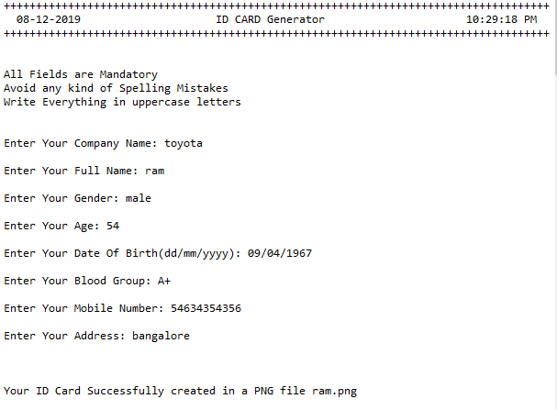

**Input**:

**Output:**

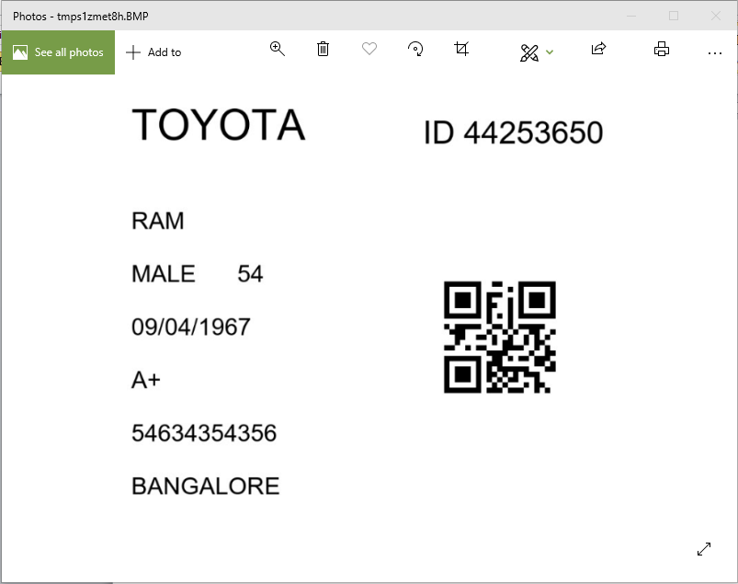

**Input:**

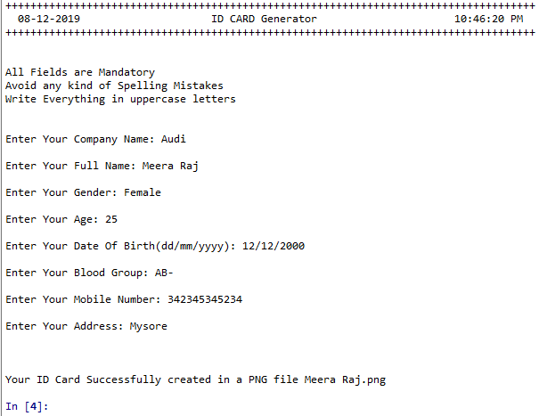

**Output:**

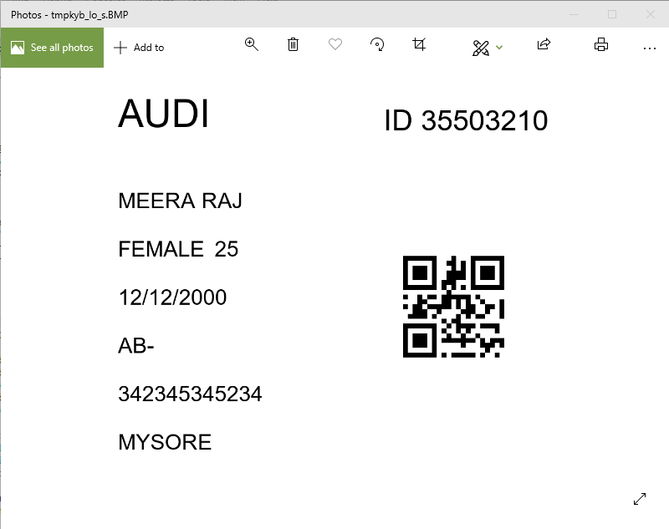

**ID cards and associated QRCode- stored in same folder:**

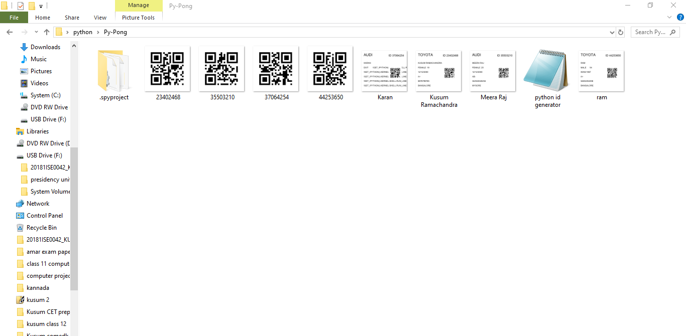

**REFERENCE**

1. <https://github.com/Sandeeppushp/ID-Card-Generator/blob/master/ID%20Card%20Generator(Py3).py>
2. <https://www.youtube.com/watch?v=0W8ddb0y3eI>
3. <https://www.studentprojectguide.com/projectreport/id-card-generator-system/>
4. <https://github.com/mnooner256/pyqrcode>
5. <https://www.geeksforgeeks.org/working-images-python/>
6. <https://realpython.com/what-is-pip/>